Dublin Valley Farms

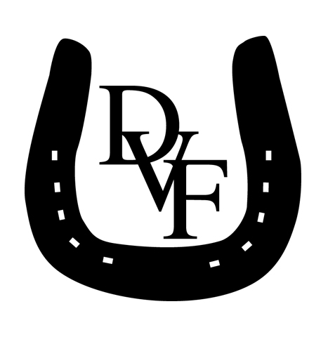

**STALLION FEE: $__________**



4040 Township Road 606 Fredericksburg, Ohio 44627

Phone: 330-473-5863 or 330-231-6209 email-info@dublinvalleyfarms.com

**To Order Semen: 330-473-5863 (Call To Order Semen by 10:00 a.m.)**

**2026 SLAY BREEDING APPLICATION**

Name of Mare:

Tattoo #: ____________________________ Color: ____________________________ Year of Birth:

Sire of Mare: _________________________________________ Dam of Mare:

Sire of Dam: ____________________________ Record of Mare: ____________________ Earnings:

Owner of Mare:

Phone: _________________________________________ Email:

Billing Address:

Was Mare bred in 2025? YES_______ NO _______ If “Yes”, to what Stud?

Results: Maiden _______ Barren _______ Aborted _______ In Foal _______ Last Breeding Date:

Does mare have any fertility or foaling problems? YES _______ NO _______ If “yes”, please explain:

______________________________________________________________________________________________________________

Will mare be boarded at or bred at Dublin Valley Farms? YES___ NO___ If “no”, where will semen be sent? ____________________

Name_______________________________Address____________________________________________________________________

_______________________________________________________________________________________________________________

**COMPLETE CREDIT CARD AND/OR UPS ACCOUNT INFORMATION IS REQUIRED FOR ALL SEMEN TRANSPORTATION ORDERS.**

VISA | MASTERCARD | UPS ACCT UPS Account Number_________________________________________________

*(circle one)*

Credit Card Number ______________________________________3 dig. code______________Expiration Date:_______________________

Name of Cardholder: _____________________________________________________ Phone: (_____)

Address:

**ALL CHARGES FOR SHIPPED SEMEN ARE DUE AT TIME SERVICE IS PROVIDED.**

Dublin Valley Farms shall not be liable for, and is hereby released from, liability with respect to any injury, disease or death resulting from breeding or boarding. Dublin Valley Farms reserves the right to reject any equine physically unfit and to have veterinarian tests / medical attention given, as deemed necessary. All charges for boarded horses including, but not limited to, Veterinary fees, Blacksmith fees, Board, etc., are to be paid within 30 days of billing. Breeding fees are due and payable when mare has a live foal (which stands and nurses without assistance), or changes ownership, whichever comes first. All accounts, board bills, etc., must be settled before the equine is removed from Dublin Valley Farms.. Overdue accounts will be charged a late fee at a rate of 2% per month.

Owner’s Signature: _____________________________________________________ Date:

Approved by: __________________________________________________________ Date:

**THIS IS ONLY AN APPLICATION. YOUR MARE IS NOT BOOKED UNTIL APPROVED ABOVE.**